**UNIT-1**

1. (a) Explain the applications of Finite Element method.

(b)What are the merits and demerits of FEM

1. (a)Explain Stress and equilibrium for a 3D body.

(b)write stress-strain relations for 3D body?

1. (a)what is meant by plane stress and plane strain conditions explain with examples.

(b)Explain briefly about potential energy approach and Explain any weighted residual method.

1. (a)Explain strain displacement relations ?

(b)In a plane strain problem we have and  and  Determine the value of stress .

1. (a)If a displacement field is described by  determineand 

at x=1 and y=0.

1. Determine the displacements of nodes of the spring system shown in figure.

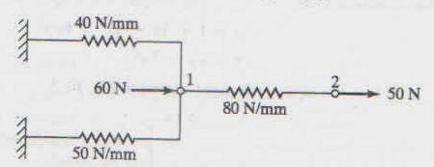

1. (a) Explain the Gelarkin Method.

(b) Develop a deforamtion field u(x,y) that describes the deformation of the finite element shown. From this determine and .

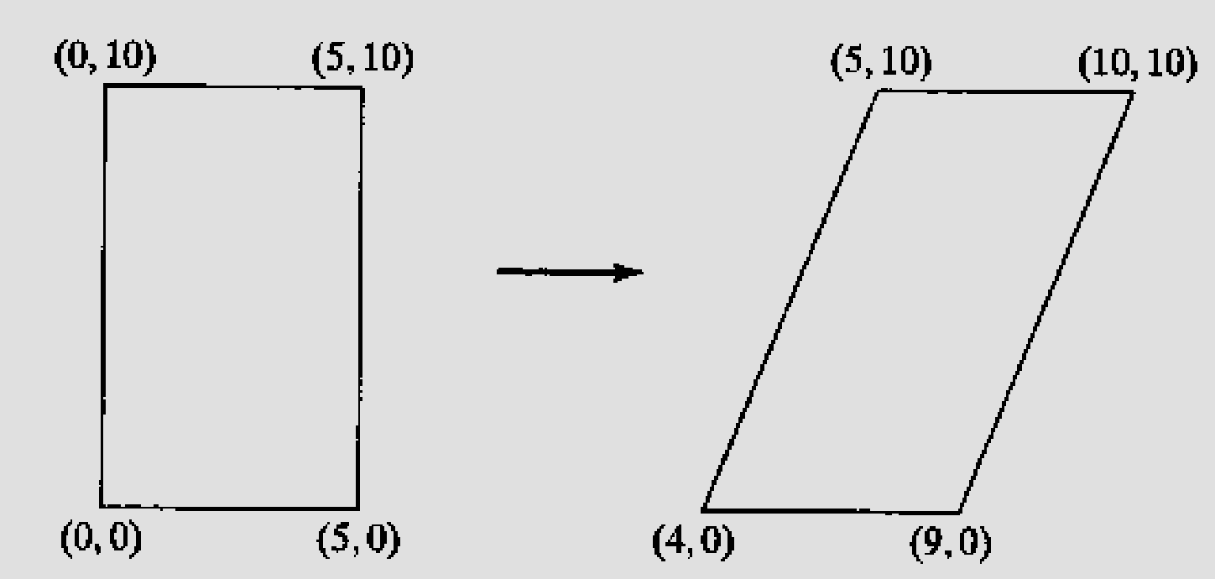

1. a)

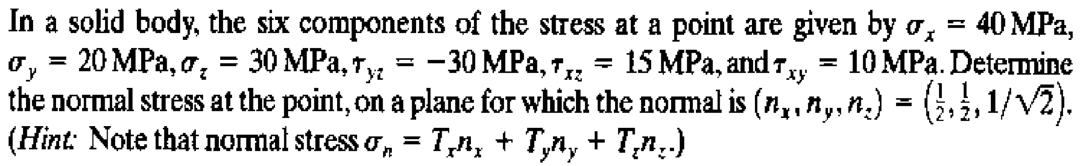

(b)

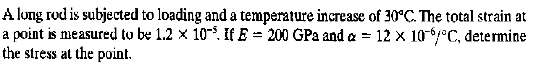

**UNIT 2**

1. (a)Derive strain displacement and stiffness matrix for 1-D bar element.

(b)Derive the Global load Vector for 1-Dimensional Bar

1. (a)Consider the bar in below figure. Cross sectional area Ae = 1.2 in.2, and Yong’s modulus E = 30 x 106 psi, if q1 = 0.02 in. and q2 = 0.025 in., determine the following 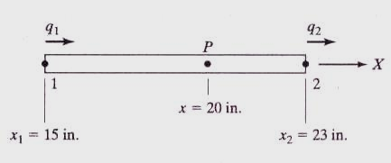

The displacement at point P,

The strain ε and stress σ

The element stiffness matrix, and

The strain energy in the element

**(b)** write the properties of ‘K’

1. (a)What are the various methods to treat boundary conditions .Explain any one.

(b) Define shape function? Derive shape function in terms of Cartesian coordinates?

1. Consider a bar as shown in figure. Young’s Modulus E = 2 x 105 N/mm2. A1 = 2cm2, A2 = 1cm2 and force of 100N. Determine the nodal displacement.

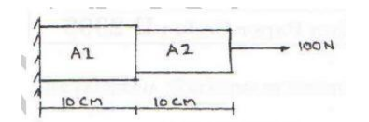

1. Consider the bar shown in below figure. An axial load P = 200 x 103 N is applied as shown. Using the penalty approach for handling boundary conditions, do the following 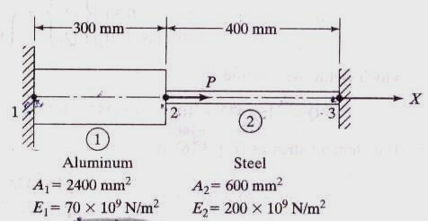
   1. Determine the nodal displacements.
   2. Determine the stress in each material.
   3. Determine the reaction forces.
2. In Fig a load P=60x105N is applied as shown. Determine the displacement field, stress and support reactions in the body take E=20X105N/mm2.

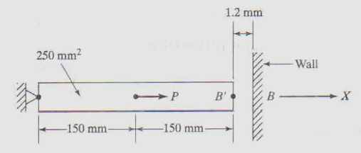

1. An Axial load P=300x103N is applied at 200 to the rod as shown. The temperature is then raised to 600C. Determine the displacement field, stress and support reactions in the body.

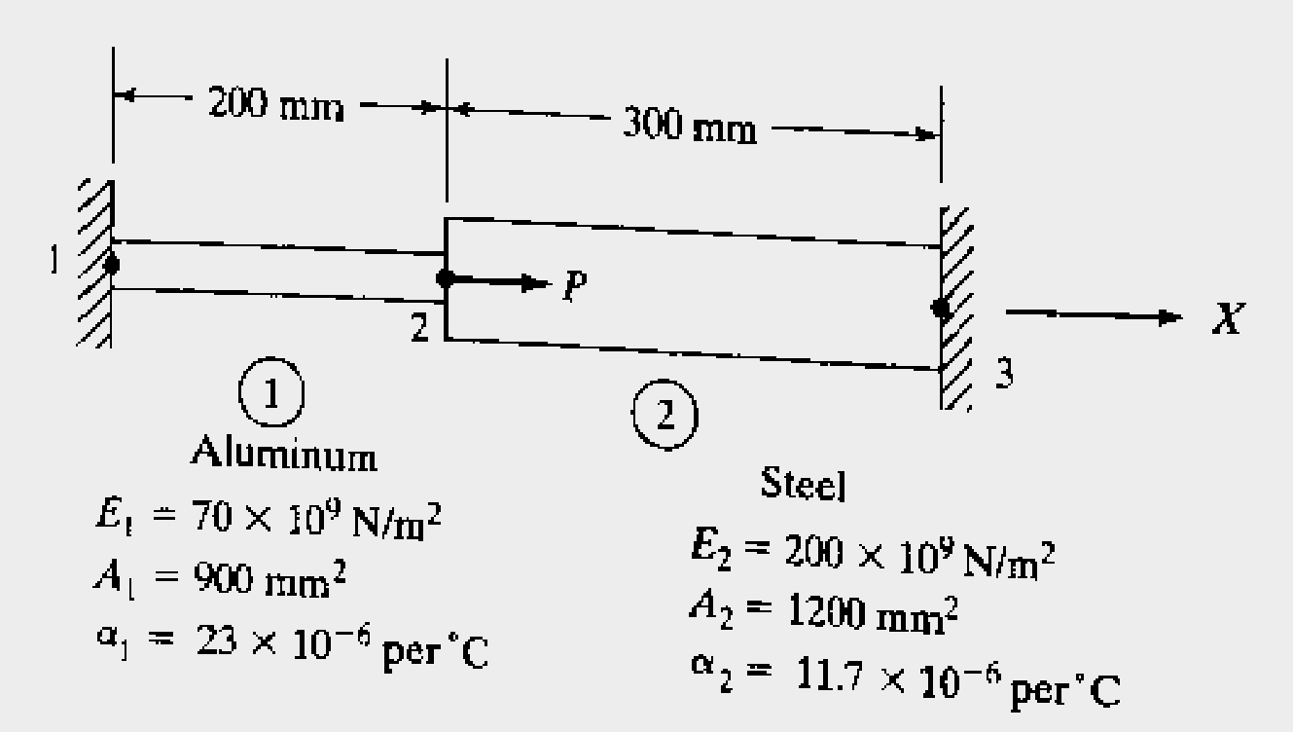

1. The structure is shown in fig. is subjected toan increases temperature, 800C. Determine the displacement field, stress and support reactions in the body.

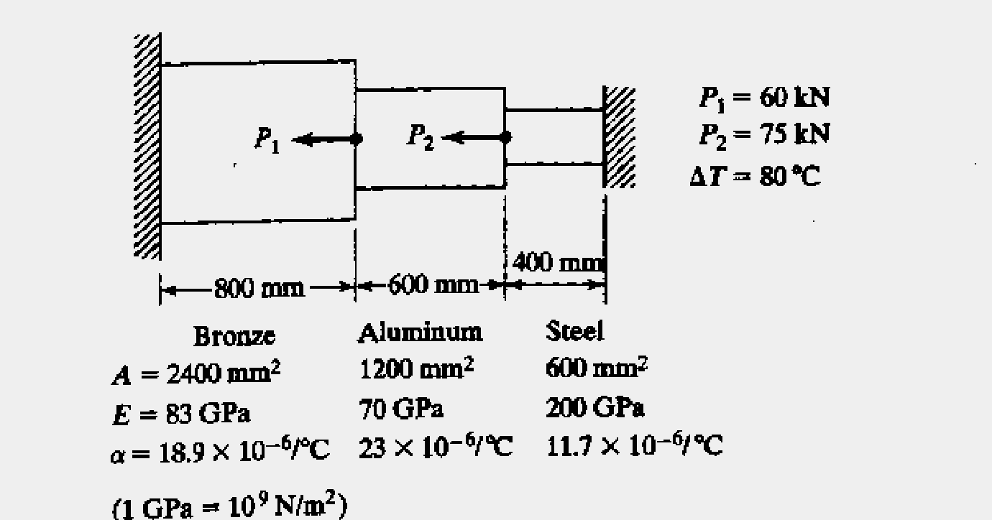

**UNIT 3**

1. For the two-bar truss shown in figure, determine the displacements and stress. A1=500mm2 , A2=1200mm2 , E=2x105 N/mm2

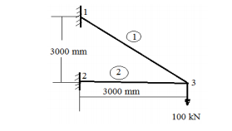

1. (a)Differentiate between local and global coordinates?

b). Derive the stiffness matrix for truss element?

3. For the truss shown in Fig.1 below, fin the assembled stiffness matrix. E1=E2=200 Gpa

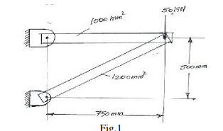

1. Derive the element stifness Matrix for Bema element.
2. For the beam and loading shown in figure determine : (i) slope at 2 and 3 (ii) vertical deflection at midpoint of the load Take E=200GPa, I=4 x 106 mm4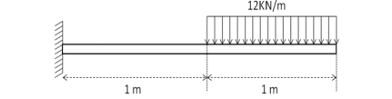

1. For the beam shown in figure calculate the deflection under the load for the beam.

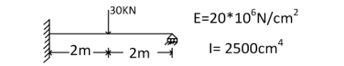

1. Determine the nodal displacement and element stresses for the thin plate shown in figure

Body force is neglected. Take, Thickness (t) = 10mm, Young’s modulus (E) = 2x102mm2,

Poisson’s ratio (v) = 0.25. Assume plane stress condition.

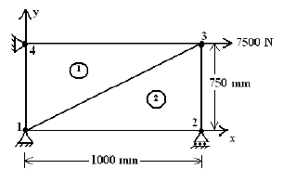

1. The plane truss shown in Figure. is composed of members having 0.01 m2 cross section area

and modulus of elasticity E = 70 GPa. (a) Assemble the global stiffness matrix.

(b) Compute the nodal displacements in the global coordinate system

(c) Compute the axial stress in each element.

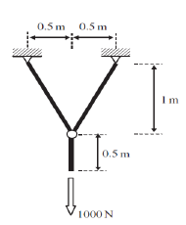

1. For the two bar truss shown in fig. Determine the displacemnt at node 1 and find the stress in element 1-3.

.. 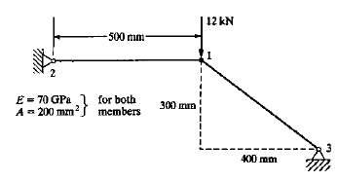

**UNIT4**

1.Derive the shape functions for a triangular linear element in global Co-ordinate

system.

2.Derive strain displacement matrix for a triangular Element.

3.Determine the deflection at the point load application using finite element model.

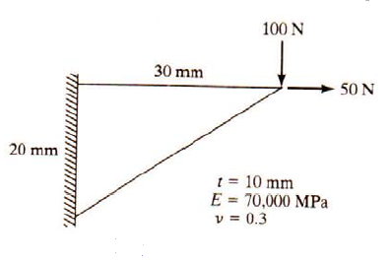

4.For the Triangular element shown in fig obtain strain displacement matrix and determine the strains 

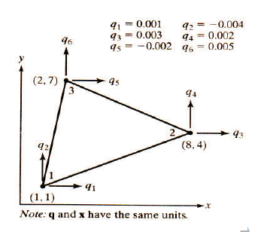

5Derive the strain displacement relationship matrix for CST element

6Derive the stiffness matrix for CST element.

6Calculate the stiffness matrix for the element shown in figure? Co-ordinates are

given in mm. Assume plane stress conditions. Take E=2.1X105 N/mm2, ʋ=0.25, t=10mm.

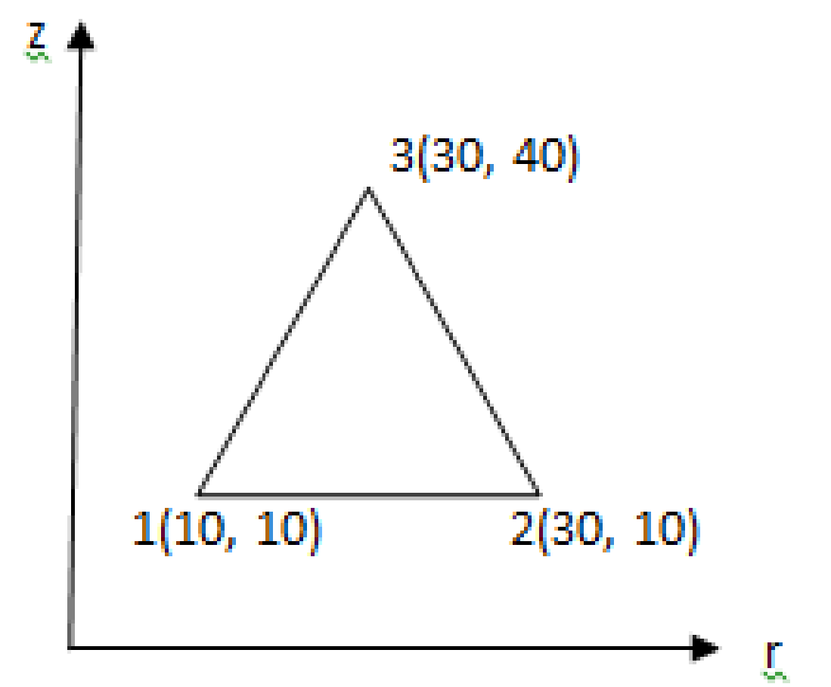

1. Derive the stiffness matrix for axisymmetric element?
2. Determiine the element stiffness matrix for the axisymmetric triangular element shown in figure. Assume E = 2 x 105 N/mm2 , µ =0.3. The coordinates are in centimeters

z

(0,4) 3

1 2

(0,0) (6,0) r

1. Evaluate the element stiffness matrix for the triangular element shown in fig under plane strain condition. Assume the following values: E=200 GPa, µ =0.25, t= 1 mm.



y 

(3,5)

(0,0) (6,0) 

**UNIT 5**

1. Derive the shape functions for a four – noded quadrilateral element using natural coordinates
2. Derive the stiffness matrix for isoparametric quadrilateral element.
3. Determine the Cartesian coordinates of the point P which has local coordinates € = 0.8 and ῃ = 0.6 as shown in fig.

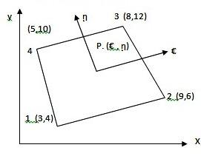

1. For the element shown in fig, determine the Jacobian matrix

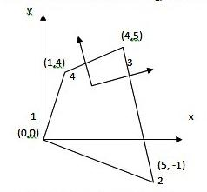

1. For a four noded rectangular element shown in fig determine the following:
2. Jacobian matrix
3. Strain – displacement matrix
4. Element strains and

Element stresses

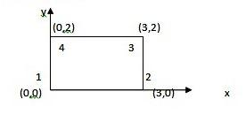

**UNIT 6**

1.Determine the Eigen values and Eigen vectors of the bar shown below figure . Take E=200 GPa, ρ = 2800 kg/m3, A=0.258 m2, and L=0.4 m.



2. Calculate natural frequencies and mode shapes of the stepped bar shown in figure. Consider Young’s modulus as 200 GPa and density as 7200 kg/m3

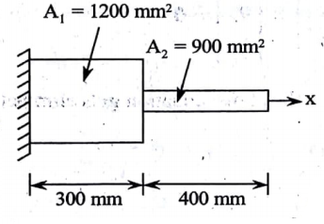

3.Determine all natural frequencies of the simply supported beam as shown in figure?



4.Determine the first two natural frequencies for the fixed-fixed beam made of steel having the following properties: Material properties: Modulus of elasticity =209 GPa, Poisson’s ratio = 0.3, mass density=7800 kg/m3 . Geometric Properties: Length 0.75m , cross-sectional area =625mm2 , moment of inertia=34700 mm4

